
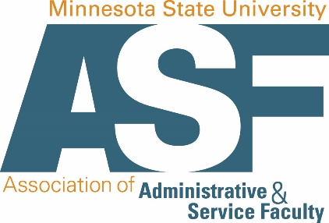

Dear ______________,
My name is _____ and I serve as the __________ at _________ University. I am a member of the Minnesota State University Association of Administrative and Service Faculty (MSUAASF) and Teamsters Local 320 who work hard to ensure the academic and personal success of university students. Our members have stepped up to challenges during the COVID-19 pandemic to provide much needed services and advocacy for Minnesota university students.

The MSUAASF collective bargaining agreement was settled in Fall 2019 through negotiations with Minnesota State Colleges and Universities. In this contract ratification, we bargained health insurance benefits and a meager cost of living increase that went into effect on January 8, 2020. The Minnesota State universities have been building these contract settlements into their budgetary plans and are prepared for the terms of the settlement.
HF2768 was adopted by the House State Government Finance Committee on April 24, 2020, and it was sent on to the Ways and Means Committee. We need support for both HF2768 and SF4006 in order to get our contract through this final approval phase. Can we count on you to help the 800+ Administrative and Service Faculty around the state maintain the salary and benefits that were bargained for in good faith before the COVID-19 pandemic was even on the radar?

Working hard for Minnesota State university students,

ASF Member’s name

